ASSIGNMENT- 4

CUSTOMER SEGMENTATION ANALYSIS

|  |  |
| --- | --- |
| Assignment Date | 25 Nov 2022 |
| Team ID | PNT2022TMID49030 |
| Project Name | Car Resale Value Prediction |
| Maximum Marks | 2 Marks |

**Importing the libraries import** pandas **as** pd **import** numpy **as** np

**import** matplotlib.pyplot **as** plt

**import** seaborn **as** sns

## Loading the dataset:

**Input:**

df **=** pd**.**read_csv('Mall_Customers.csv') df

## Output:

|  |  |  |  |  |  |
| --- | --- | --- | --- | --- | --- |
|  | CustomerID | Gender | Age | Annual Income (k$) | Spending Score (1-100) |
| 0 | 1 | Male | 19 | 15 | 39 |
| 1 | 2 | Male | 21 | 15 | 81 |
| 2 | 3 | Female | 20 | 16 | 6 |
| 3 | 4 | Female | 23 | 16 | 77 |
| 4 | 5 | Female | 31 | 17 | 40 |
| ... | ... | ... | ... | ... | ... |
| 195 | 196 | Female | 35 | 120 | 79 |
| 196 | 197 | Female | 45 | 126 | 28 |
| 197 | 198 | Male | 32 | 126 | 74 |
| 198 | 199 | Male | 32 | 137 | 18 |
| 199 | 200 | Male | 30 | 137 | 83 |

200 rows × 5 columns

## Encoding Categorical Columns Input:

**from** sklearn.preprocessing **import** LabelEncoderle **=** LabelEncoder() df['Gender'] **=** le**.**fit_transform(df['Gender']) df

## Output:

|  |  |  |  |  |  |  |
| --- | --- | --- | --- | --- | --- | --- |
|  | **CustomerID** | **Gender** | **Age** | **Annual Income (k$)** | **Spending Score (1-100)** | **Cluster** |
| **0** | 1 | 1 | 19 | 15.00 | 39 | 2 |
| **1** | 2 | 1 | 21 | 15.00 | 81 | 2 |
| **2** | 3 | 0 | 20 | 16.00 | 6 | 2 |
| **3** | 4 | 0 | 23 | 16.00 | 77 | 2 |
| **4** | 5 | 0 | 31 | 17.00 | 40 | 2 |
| **...** | ... | ... | ... | ... | ... | ... |
| **195** | 196 | 0 | 35 | 120.00 | 79 | 3 |
| **196** | 197 | 0 | 45 | 126.00 | 28 | 1 |
| **197** | 198 | 1 | 32 | 126.00 | 74 | 3 |
| **198** | 199 | 1 | 32 | 60.55 | 18 | 1 |
| **199** | 200 | 1 | 30 | 60.55 | 83 | 3 |

200 rows × 6 columns

## Visualizations Univariate Analysis

**Input:**

plt.hist(df['Age'])

## Output:

(array([31., 19., 34., 29., 16., 26., 15., 10., 6., 14.]),

array([18. , 23.2, 28.4, 33.6, 38.8, 44. , 49.2, 54.4, 59.6, 64.8, 70. ]),

)

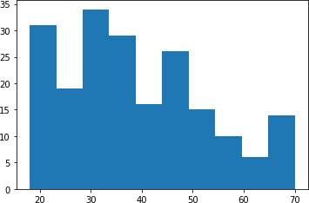

## Input:

plt**.**hist(df['Annual Income (k$)'])

## Output:

(array([24., 22., 28., 38., 30., 36., 8., 6., 4., 4.]),

array([ 15. , 27.2, 39.4, 51.6, 63.8, 76. , 88.2, 100.4, 112.6,

124.8, 137. ]),

)

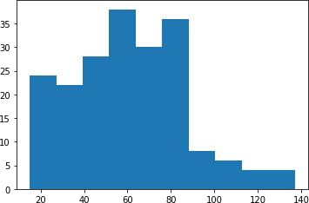

## Input:

plt.hist(df['Spending Score (1-100)'])

## Output:

(array([16., 20., 10., 17., 35., 37., 11., 24., 14., 16.]),

array([ 1. , 10.8, 20.6, 30.4, 40.2, 50. , 59.8, 69.6, 79.4, 89.2, 99. ]),

)

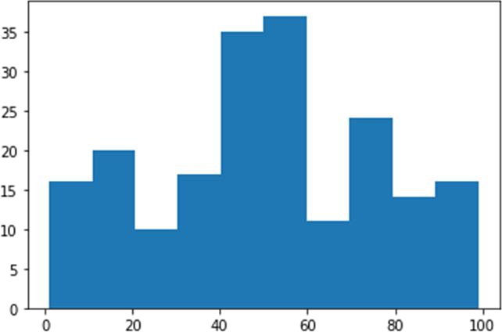

## Input:

sns**.**countplot(df['Gender'])

## Output:

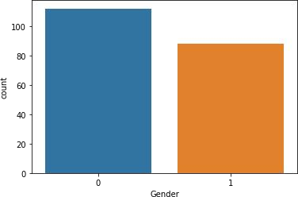

**Bi-Variate Analysis Input:**

sns.scatterplot(df['Annual Income (k$)'], df['Spending Score (1-100)'])

## Output:

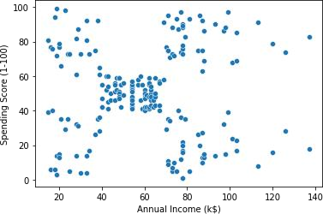

**Input:**

sns.barplot(df['Gender'], df['Age'])

## Output:

**Input:**

sns**.**heatmap(df**.**corr(), annot **= True**)

## Output:

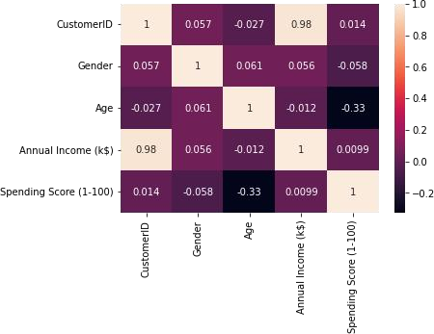

**Multi-variate Analysis Input:**

sns.pairplot(df)

**output:**

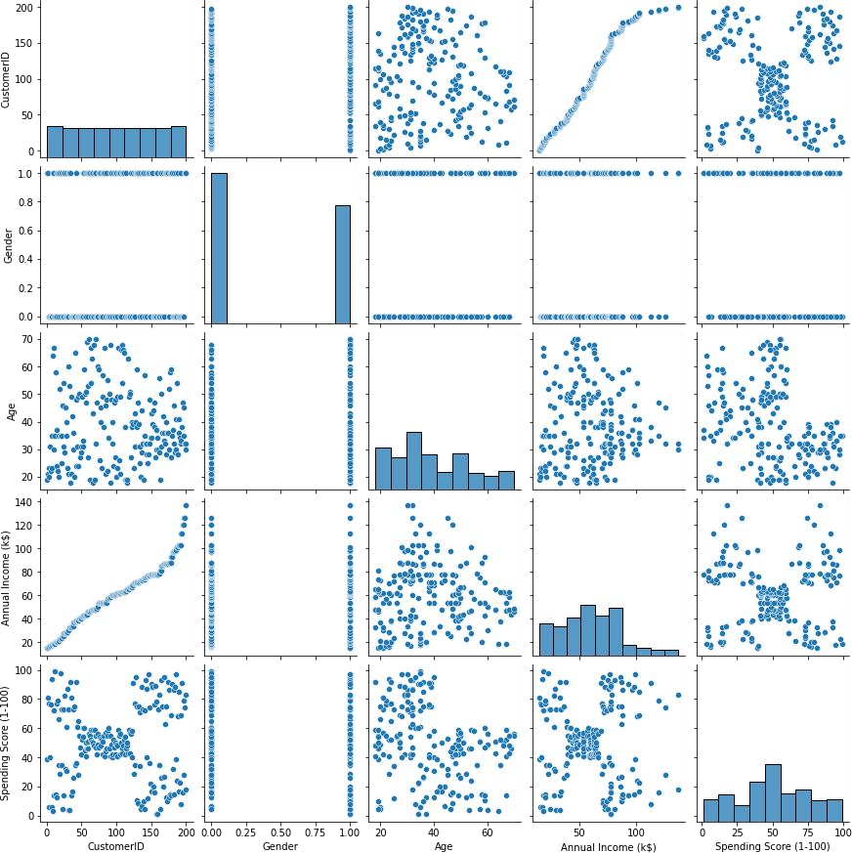

# Descriptive Statistics

## Input:

df**.**info()

## Output:

RangeIndex: 200 entries, 0 to 199Data columns (total 5 columns):

# Column Non-Null Count Dtype

|  |  |  |  |  |  |  |  |
| --- | --- | --- | --- | --- | --- | --- | --- |
| 0 |  | CustomerID |  | 200 | non-null |  | int64 |
| 1 |  | Gender |  | 200 | non-null |  | int64 |
| 2 |  | Age |  | 200 | non-null |  | int64 |
| 3 |  | Annual Income | (k$) | 200 | non-null |  | int64 |

4 Spending Score (1-100) 200 non-null int64 dtypes: int64(5)

memory usage: 7.9 KB

## Input:

df**.**describe()

## Output:

**CustomerID Gender Age Annual Income (k$) Spending Score (1-100)**

|  |  |  |  |  |  |
| --- | --- | --- | --- | --- | --- |
|  | **CustomerID** | **Gender** | **Age** | **Annual Income (k$)** | **Spending Score (1-100)** |
| **count** | 200.000000 | 200.000000 | 200.000000 | 200.000000 | 200.000000 |
| **mean** | 100.500000 | 0.440000 | 38.850000 | 60.560000 | 50.200000 |
| **std** | 57.879185 | 0.497633 | 13.969007 | 26.264721 | 25.823522 |
| **min** | 1.000000 | 0.000000 | 18.000000 | 15.000000 | 1.000000 |
| **25%** | 50.750000 | 0.000000 | 28.750000 | 41.500000 | 34.750000 |
| **50%** | 100.500000 | 0.000000 | 36.000000 | 61.500000 | 50.000000 |
| **75%** | 150.250000 | 1.000000 | 49.000000 | 78.000000 | 73.000000 |
| **max** | 200.000000 | 1.000000 | 70.000000 | 137.000000 | 99.000000 |

|  |  |  |
| --- | --- | --- |
| **Input:** |  | |
| df.skew() |
| **Output:** |
| CustomerID |  | 0.000000 |
| Gender |  | 0.243578 |
| Age |  | 0.485569 |
| Annual Income | (k$) | 0.321843 |
| Spending Score | (1-100) | -0.047220 |
| dtype: float64 |  |  |
| **Input:** |  |  |
| df**.**kurt() |  |  |
| **Output:** |  |  |
| CustomerID |  | -1.200000 |
| Gender |  | -1.960375 |
| Age |  | -0.671573 |
| Annual Income | (k$) | -0.098487 |

Spending Score (1-100) -0.826629 dtype: float64

## Input:

df**.**corr()

## Output:

|  |  |  |  |  |  |
| --- | --- | --- | --- | --- | --- |
|  | CustomerID | Gender | Age | Annual Income (k$) | Spending Score (1-100) |
| CustomerID | 1.000000 | 0.057400 | -0.026763 | 0.977548 | 0.013835 |
| Gender | 0.057400 | 1.000000 | 0.060867 | 0.056410 | -0.058109 |
| Age | -0.026763 | 0.060867 | 1.000000 | -0.012398 | -0.327227 |
| Annual Income (k$) | 0.977548 | 0.056410 | -0.012398 | 1.000000 | 0.009903 |
| Spending Score (1-100) | 0.013835 | -0.058109 | -0.327227 | 0.009903 | 1.000000 |
| **Input:** |  |  |  |  |  |
| df**.**var() |  |  |  |  |  |
| **Output:** |  |  |  |  |  |
| CustomerID |  | 3350.000000 | | | |
| Gender |  | 0.247638 | | | |
| Age |  | 195.133166 | | | |
| Annual Income | (k$) | 689.835578 | | | |
| Spending Score | (1-100) | 666.854271 | | | |
| dtype: float64 |  |  | | | |
| **Input:** |  |  | | | |
| df**.**std() |  |  | | | |
| **Output:**  CustomerID |  | 57.879185 | | | |
| Gender |  | 0.497633 | | | |
| Age |  | 13.969007 | | | |
| Annual Income | (k$) | 26.264721 | | | |

Spending Score (1-100) 25.823522

dtype: float64

## Checking for missing values Input:

df**.**isna()**.**sum()

|  |  |  |
| --- | --- | --- |
| **Output:** |  | |
| CustomerID |  | 0 |
| Gender |  | 0 |
| Age |  | 0 |
| Annual Income | (k$) | 0 |

Spending Score (1-100) 0

dtype: int64

## Input:

df**.**isna()**.**sum()**.**sum()

## Output:

0

## Input:

df**.**duplicated()**.**sum()

## Output:

0

# Finding & Handling Ouliers

## Input:

quantile **=** df**.**quantile(q **=** [0.25, 0.75])quantile

## Output:

|  |  |  |  |  |  |
| --- | --- | --- | --- | --- | --- |
|  | **CustomerID** | **Gender** | **Age** | **Annual Income (k$)** | **Spending Score (1-100)** |
| **0.25** | 50.75 | 0.0 | 28.75 | 41.5 | 34.75 |
| **0.75** | 150.25 | 1.0 | 49.00 | 78.0 | 73.00 |

**Input:**

IQR **=** quantile**.**iloc[1] **-** quantile**.**iloc[0]IQR

## Output:

CustomerID 99.50

Gender 1.00

Age 20.25

Annual Income (k$) 36.50

Spending Score (1-100) 38.25

dtype: float64

## Input:

upper **=** quantile**.**iloc[1] **+** (1.5 **\***IQR)upper

|  |  |  |  |
| --- | --- | --- | --- |
| **Output:** |  | | |
| CustomerID |  | 299.500 | |
| Gender |  | 2.500 | |
| Age |  | 79.375 | |
| Annual Income | (k$) | 132.750 | |
| Spending Score (1-100)dtype: | | 130.375 |  |
| float64 | |  |  |
| **Input:** | |  |  |
| lower **=** quantile**.**iloc[0]lower | | **-** (1.5**\*** | IQR) |
| **Output:** | |  |  |
| CustomerID | | -98.500 |  |
| Gender | | -1.500 |  |
| Age | | -1.625 |  |
| Annual Income (k$) | | -13.250 |  |
| Spending Score (1-100)dtype: | | -22.625 |  |
| float64 | |  |  |
| **Input:** | |  |  |
| df**.**mean() | |  |  |
| **Output:** | |  |  |
| CustomerID | | 100.50 |  |
| Gender | | 0.44 |  |
| Age | | 38.85 |  |
| Annual Income (k$) | | 60.56 |  |
| Spending Score (1-100) dtype: float64 | | 50.20 |  |
| **Input:** | |  |  |
| df['Annual Income (k$)']**.**max() | |  |  |
| **Output:** | |  |  |
| 137 | |  |  |
| **Input:** | |  |  |
| sns**.**boxplot(df['CustomerID']) | |  |  |
| **Output:** | |  |  |

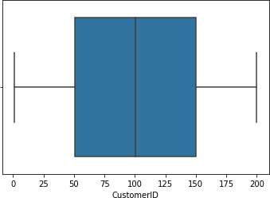

## Input:

sns**.**boxplot(df['Gender'])

## Output:



**Input:**

sns**.**boxplot(df['Age'])

## Output:

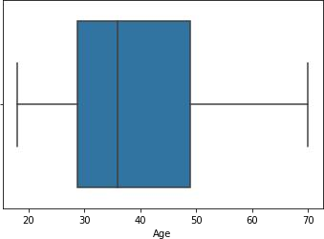

**Input:**

sns**.**boxplot(df['Annual Income (k$)'])

## Output:

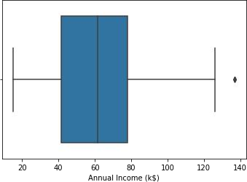

**Input:**

df['Annual Income (k$)'] **=** np**.**where(df['Annual Income (k$)'] **>** 132.750,60.55, df['Annual Income (k$)']) sns**.**boxplot(df['Annual Income (k$)'])

## Output:

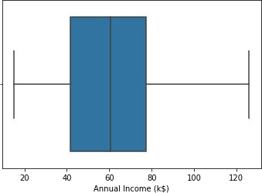

**Input:**

df['Annual Income (k$)']**.**max()

## Output:

126.0

## Input:

sns**.**boxplot(df['Spending Score (1-100)'])

## Output:

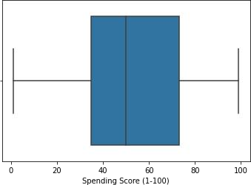

**Scaling the data**

## Input:

**from** sklearn.preprocessing **import** StandardScalerss **=**

StandardScaler()**.**fit_transform(df) ss

## Output:

|  |  |  |  |  |
| --- | --- | --- | --- | --- |
| array([[-1.7234121 , | 1.12815215, | -1.42456879, | -1.78843062, | -0.43480148], |
| [-1.70609137, | 1.12815215, | -1.28103541, | -1.78843062, | 1.19570407], |
| [-1.68877065, | -0.88640526, | -1.3528021 , | -1.74850629, | -1.71591298], |
| [-1.67144992, | -0.88640526, | -1.13750203, | -1.74850629, | 1.04041783], |
| [-1.6541292 , | -0.88640526, | -0.56336851, | -1.70858195, | -0.39597992], |
| [-1.63680847, | -0.88640526, | -1.20926872, | -1.70858195, | 1.00159627], |
| [-1.61948775, | -0.88640526, | -0.27630176, | -1.66865761, | -1.71591298], |
| [-1.60216702, | -0.88640526, | -1.13750203, | -1.66865761, | 1.70038436], |
| [-1.5848463 , | 1.12815215, | 1.80493225, | -1.62873328, | -1.83237767], |
| [-1.56752558, | -0.88640526, | -0.6351352 , | -1.62873328, | 0.84631002], |
| [-1.55020485, | 1.12815215, | 2.02023231, | -1.62873328, | -1.4053405 ], |
| [-1.53288413, | -0.88640526, | -0.27630176, | -1.62873328, | 1.89449216], |
| [-1.5155634 , | -0.88640526, | 1.37433211, | -1.58880894, | -1.36651894], |
| [-1.49824268, | -0.88640526, | -1.06573534, | -1.58880894, | 1.04041783], |
| [-1.48092195, | 1.12815215, | -0.13276838, | -1.58880894, | -1.44416206], |
| [-1.46360123, | 1.12815215, | -1.20926872, | -1.58880894, | 1.11806095], |
| [-1.4462805 , | -0.88640526, | -0.27630176, | -1.5488846 , | -0.59008772], |
| [-1.42895978, | 1.12815215, | -1.3528021 , | -1.5488846 , | 0.61338066], |
| [-1.41163905, | 1.12815215, | 0.94373197, | -1.46903593, | -0.82301709], |
| [-1.39431833, | -0.88640526, | -0.27630176, | -1.46903593, | 1.8556706 ], |
| [-1.3769976 , | 1.12815215, | -0.27630176, | -1.42911159, | -0.59008772], |
| [-1.35967688, | 1.12815215, | -0.99396865, | -1.42911159, | 0.88513158], |
| [-1.34235616, | -0.88640526, | 0.51313183, | -1.38918726, | -1.75473454], |
| [-1.32503543, | 1.12815215, | -0.56336851, | -1.38918726, | 0.88513158], |
| [-1.30771471, | -0.88640526, | 1.08726535, | -1.26941425, | -1.4053405 ], |
| [-1.29039398, | 1.12815215, | -0.70690189, | -1.26941425, | 1.23452563], |
| [-1.27307326, | -0.88640526, | 0.44136514, | -1.26941425, | -0.7065524 ], |
| [-1.25575253, | 1.12815215, | -0.27630176, | -1.26941425, | 0.41927286], |
| [-1.23843181, | -0.88640526, | 0.08253169, | -1.22948991, | -0.74537397], |
| [-1.22111108, | -0.88640526, | -1.13750203, | -1.22948991, | 1.42863343], |
| [-1.20379036, | 1.12815215, | 1.51786549, | -1.18956557, | -1.7935561 ], |
| [-1.18646963, | -0.88640526, | -1.28103541, | -1.18956557, | 0.88513158], |
| [-1.16914891, | 1.12815215, | 1.01549866, | -1.06979256, | -1.7935561 ], |
| [-1.15182818, | 1.12815215, | -1.49633548, | -1.06979256, | 1.62274124], |
| [-1.13450746, | -0.88640526, | 0.7284319 , | -1.06979256, | -1.4053405 ], |
| [-1.11718674, | -0.88640526, | -1.28103541, | -1.06979256, | 1.19570407], |
| [-1.09986601, | -0.88640526, | 0.22606507, | -1.02986823, | -1.28887582], |
| [-1.08254529, | -0.88640526, | -0.6351352 , | -1.02986823, | 0.88513158], |
| [-1.06522456, | -0.88640526, | -0.20453507, | -0.91009522, | -0.93948177], |
| [-1.04790384, | -0.88640526, | -1.3528021 , | -0.91009522, | 0.96277471], |
| [-1.03058311, | -0.88640526, | 1.87669894, | -0.87017088, | -0.59008772], |
| [-1.01326239, | 1.12815215, | -1.06573534, | -0.87017088, | 1.62274124], |
| [-0.99594166, | 1.12815215, | 0.65666521, | -0.83024654, | -0.55126616], |
| [-0.97862094, | -0.88640526, | -0.56336851, | -0.83024654, | 0.41927286], |
| [-0.96130021, | -0.88640526, | 0.7284319 , | -0.83024654, | -0.86183865], |
| [-0.94397949, | -0.88640526, | -1.06573534, | -0.83024654, | 0.5745591 ], |
| [-0.92665877, | -0.88640526, | 0.80019859, | -0.79032221, | 0.18634349], |

|  |  |  |  |  |  |
| --- | --- | --- | --- | --- | --- |
| [-0.90933804, | -0.88640526, | -0.85043527, | -0.79032221, |  | -0.12422899], |
| [-0.89201732, | -0.88640526, | -0.70690189, | -0.79032221, |  | -0.3183368 ], |
| [-0.87469659, | -0.88640526, | -0.56336851, | -0.79032221, |  | -0.3183368 ], |
| [-0.85737587, | -0.88640526, | 0.7284319 , | -0.71047353, |  | 0.06987881], |
| [-0.84005514, | 1.12815215, | -0.41983513, | -0.71047353, |  | 0.38045129], |
| [-0.82273442, | -0.88640526, | -0.56336851, | -0.6705492 | , | 0.14752193], |
| [-0.80541369, | 1.12815215, | 1.4460988 , | -0.6705492 | , | 0.38045129], |
| [-0.78809297, | -0.88640526, | 0.80019859, | -0.6705492 | , | -0.20187212], |
| [-0.77077224, | 1.12815215, | 0.58489852, | -0.6705492 | , | -0.35715836], |
| [-0.75345152, | -0.88640526, | 0.87196528, | -0.63062486, |  | -0.00776431], |
| [-0.73613079, | 1.12815215, | 2.16376569, | -0.63062486, |  | -0.16305055], |
| [-0.71881007, | -0.88640526, | -0.85043527, | -0.55077619, |  | 0.03105725], |
| [-0.70148935, | 1.12815215, | 1.01549866, | -0.55077619, |  | -0.16305055], |
| [-0.68416862, | 1.12815215, | 2.23553238, | -0.55077619, |  | 0.22516505], |
| [-0.6668479 , | 1.12815215, | -1.42456879, | -0.55077619, |  | 0.18634349], |
| [-0.64952717, | -0.88640526, | 2.02023231, | -0.51085185, |  | 0.06987881], |
| [-0.63220645, | -0.88640526, | 1.08726535, | -0.51085185, |  | 0.34162973], |
| [-0.61488572, | 1.12815215, | 1.73316556, | -0.47092751, |  | 0.03105725], |
| [-0.597565 , | 1.12815215, | -1.49633548, | -0.47092751, |  | 0.34162973], |
| [-0.58024427, | -0.88640526, | 0.29783176, | -0.47092751, |  | -0.00776431], |
| [-0.56292355, | -0.88640526, | 2.091999 , | -0.47092751, |  | -0.08540743], |
| [-0.54560282, | 1.12815215, | -1.42456879, | -0.47092751, |  | 0.34162973], |
| [-0.5282821 , | -0.88640526, | -0.49160182, | -0.47092751, |  | -0.12422899], |
| [-0.51096138, | 1.12815215, | 2.23553238, | -0.43100318, |  | 0.18634349], |
| [-0.49364065, | -0.88640526, | 0.58489852, | -0.43100318, |  | -0.3183368 ], |
| [-0.47631993, | -0.88640526, | 1.51786549, | -0.39107884, |  | -0.04658587], |
| [-0.4589992 , | -0.88640526, | 1.51786549, | -0.39107884, |  | 0.22516505], |
| [-0.44167848, | 1.12815215, | 1.4460988 , | -0.23138149, |  | -0.12422899], |
| [-0.42435775, | 1.12815215, | -0.92220196, | -0.23138149, |  | 0.14752193], |
| [-0.40703703, | -0.88640526, | 0.44136514, | -0.23138149, |  | 0.10870037], |
| [-0.3897163 , | 1.12815215, | 0.08253169, | -0.23138149, |  | -0.08540743], |
| [-0.37239558, | -0.88640526, | -1.13750203, | -0.23138149, |  | 0.06987881], |
| [-0.35507485, | -0.88640526, | 0.7284319 , | -0.23138149, |  | -0.3183368 ], |
| [-0.33775413, | 1.12815215, | 1.30256542, | -0.23138149, |  | 0.03105725], |
| [-0.3204334 , | 1.12815215, | -0.06100169, | -0.23138149, |  | 0.18634349], |
| [-0.30311268, | 1.12815215, | 2.02023231, | -0.23138149, |  | -0.35715836], |
| [-0.28579196, | -0.88640526, | 0.51313183, | -0.23138149, |  | -0.24069368], |
| [-0.26847123, | -0.88640526, | -1.28103541, | -0.23138149, |  | 0.26398661], |
| [-0.25115051, | 1.12815215, | 0.65666521, | -0.23138149, |  | -0.16305055], |
| [-0.23382978, | -0.88640526, | 1.15903204, | -0.11160848, |  | 0.30280817], |
| [-0.21650906, | -0.88640526, | -1.20926872, | -0.11160848, |  | 0.18634349], |
| [-0.19918833, | -0.88640526, | -0.34806844, | -0.07168415, |  | 0.38045129], |
| [-0.18186761, | -0.88640526, | 0.80019859, | -0.07168415, |  | -0.16305055], |
| [-0.16454688, | -0.88640526, | 2.091999 , | -0.03175981, |  | 0.18634349], |
| [-0.14722616, | 1.12815215, | -1.49633548, | -0.03175981, |  | -0.35715836], |
| [-0.12990543, | 1.12815215, | 0.65666521, | 0.00816453, |  | -0.04658587], |
| [-0.11258471, | -0.88640526, | 0.08253169, | 0.00816453, |  | -0.39597992], |
| [-0.09526399, | -0.88640526, | -0.49160182, | 0.00816453, |  | -0.3183368 ], |
| [-0.07794326, | 1.12815215, | -1.06573534, | 0.00816453, |  | 0.06987881], |
| [-0.06062254, | -0.88640526, | 0.58489852, | 0.00816453, |  | -0.12422899], |
| [-0.04330181, | -0.88640526, | -0.85043527, | 0.00816453, |  | -0.00776431], |
| [-0.02598109, | 1.12815215, | 0.65666521, | 0.04808886, |  | -0.3183368 ], |
| [-0.00866036, | 1.12815215, | -1.3528021 , | 0.04808886, |  | -0.04658587], |
| [ 0.00866036, | -0.88640526, | -1.13750203, | 0.0880132 | , | -0.35715836], |
| [ 0.02598109, | -0.88640526, | 0.7284319 , | 0.0880132 | , | -0.08540743], |
| [ 0.04330181, | 1.12815215, | 2.02023231, | 0.0880132 | , | 0.34162973], |
| [ 0.06062254, | 1.12815215, | -0.92220196, | 0.0880132 | , | 0.18634349], |

|  |  |  |  |  |  |  |
| --- | --- | --- | --- | --- | --- | --- |
| [ | 0.07794326, | 1.12815215, | 0.7284319 , | 0.0880132 , |  | 0.22516505], |
| [ | 0.09526399, | -0.88640526, | -1.28103541, | 0.0880132 , |  | -0.3183368 ], |
| [ | 0.11258471, | -0.88640526, | 1.94846562, | 0.12793754, |  | -0.00776431], |
| [ | 0.12990543, | 1.12815215, | 1.08726535, | 0.12793754, |  | -0.16305055], |
| [ | 0.14722616, | 1.12815215, | 2.091999 , | 0.12793754, |  | -0.27951524], |
| [ | 0.16454688, | 1.12815215, | 1.94846562, | 0.12793754, |  | -0.08540743], |
| [ | 0.18186761, | 1.12815215, | 1.87669894, | 0.12793754, |  | 0.06987881], |
| [ | 0.19918833, | -0.88640526, | -1.42456879, | 0.12793754, |  | 0.14752193], |
| [ | 0.21650906, | -0.88640526, | -0.06100169, | 0.16786187, |  | -0.3183368 ], |
| [ | 0.23382978, | 1.12815215, | -1.42456879, | 0.16786187, |  | -0.16305055], |
| [ | 0.25115051, | -0.88640526, | -1.49633548, | 0.20778621, |  | -0.08540743], |
| [ | 0.26847123, | -0.88640526, | -1.42456879, | 0.20778621, |  | -0.00776431], |
| [ | 0.28579196, | -0.88640526, | 1.73316556, | 0.20778621, |  | -0.27951524], |
| [ | 0.30311268, | -0.88640526, | 0.7284319 , | 0.20778621, |  | 0.34162973], |
| [ | 0.3204334 , | -0.88640526, | 0.87196528, | 0.28763488, |  | -0.27951524], |
| [ | 0.33775413, | -0.88640526, | 0.80019859, | 0.28763488, |  | 0.26398661], |
| [ | 0.35507485, | 1.12815215, | -0.85043527, | 0.28763488, |  | 0.22516505], |
| [ | 0.37239558, | -0.88640526, | -0.06100169, | 0.28763488, |  | -0.39597992], |
| [ | 0.3897163 , | -0.88640526, | 0.08253169, | 0.36748356, |  | 0.30280817], |
| [ | 0.40703703, | 1.12815215, | 0.010765 , | 0.36748356, |  | 1.58391968], |
| [ | 0.42435775, | -0.88640526, | -1.13750203, | 0.40740789, |  | -0.82301709], |
| [ | 0.44167848, | -0.88640526, | -0.56336851, | 0.40740789, |  | 1.04041783], |
| [ | 0.4589992 , | 1.12815215, | 0.29783176, | 0.44733223, |  | -0.59008772], |
| [ | 0.47631993, | 1.12815215, | 0.08253169, | 0.44733223, |  | 1.73920592], |
| [ | 0.49364065, | 1.12815215, | 1.4460988 , | 0.44733223, |  | -1.52180518], |
| [ | 0.51096138, | 1.12815215, | -0.06100169, | 0.44733223, |  | 0.96277471], |
| [ | 0.5282821 , | 1.12815215, | 0.58489852, | 0.44733223, |  | -1.5994483 ], |
| [ | 0.54560282, | 1.12815215, | 0.010765 , | 0.44733223, |  | 0.96277471], |
| [ | 0.56292355, | -0.88640526, | -0.99396865, | 0.48725657, |  | -0.62890928], |
| [ | 0.58024427, | -0.88640526, | -0.56336851, | 0.48725657, |  | 0.80748846], |
| [ | 0.597565 , | 1.12815215, | -1.3528021 , | 0.5271809 | , | -1.75473454], |
| [ | 0.61488572, | -0.88640526, | -0.70690189, | 0.5271809 | , | 1.46745499], |
| [ | 0.63220645, | -0.88640526, | 0.36959845, | 0.5271809 | , | -1.67709142], |
| [ | 0.64952717, | 1.12815215, | -0.49160182, | 0.5271809 | , | 0.88513158], |
| [ | 0.6668479 , | 1.12815215, | -1.42456879, | 0.56710524, |  | -1.56062674], |
| [ | 0.68416862, | -0.88640526, | -0.27630176, | 0.56710524, |  | 0.84631002], |
| [ | 0.70148935, | -0.88640526, | 1.30256542, | 0.60702958, |  | -1.75473454], |
| [ | 0.71881007, | 1.12815215, | -0.49160182, | 0.60702958, |  | 1.6615628 ], |
| [ | 0.73613079, | -0.88640526, | -0.77866858, | 0.64695391, |  | -0.39597992], |
| [ | 0.75345152, | -0.88640526, | -0.49160182, | 0.64695391, |  | 1.42863343], |
| [ | 0.77077224, | 1.12815215, | -0.99396865, | 0.68687825, |  | -1.48298362], |
| [ | 0.78809297, | 1.12815215, | -0.77866858, | 0.68687825, |  | 1.81684904], |
| [ | 0.80541369, | 1.12815215, | 0.65666521, | 0.68687825, |  | -0.55126616], |
| [ | 0.82273442, | -0.88640526, | -0.49160182, | 0.68687825, |  | 0.92395314], |
| [ | 0.84005514, | -0.88640526, | -0.34806844, | 0.72680259, |  | -1.09476801], |
| [ | 0.85737587, | 1.12815215, | -0.34806844, | 0.72680259, |  | 1.54509812], |
| [ | 0.87469659, | 1.12815215, | 0.29783176, | 0.72680259, |  | -1.28887582], |
| [ | 0.89201732, | 1.12815215, | 0.010765 , | 0.72680259, |  | 1.46745499], |
| [ | 0.90933804, | -0.88640526, | 0.36959845, | 0.72680259, |  | -1.17241113], |
| [ | 0.92665877, | -0.88640526, | -0.06100169, | 0.72680259, |  | 1.00159627], |
| [ | 0.94397949, | -0.88640526, | 0.58489852, | 0.72680259, |  | -1.32769738], |
| [ | 0.96130021, | -0.88640526, | -0.85043527, | 0.72680259, |  | 1.50627656], |
| [ | 0.97862094, | 1.12815215, | -0.13276838, | 0.72680259, |  | -1.91002079], |
| [ | 0.99594166, | -0.88640526, | -0.6351352 , | 0.72680259, |  | 1.07923939], |
| [ | 1.01326239, | 1.12815215, | -0.34806844, | 0.72680259, |  | -1.91002079], |
| [ | 1.03058311, | -0.88640526, | -0.6351352 , | 0.72680259, |  | 0.88513158], |
| [ | 1.04790384, | -0.88640526, | 1.23079873, | 0.76672692, |  | -0.59008772], |

|  |  |  |  |  |  |  |
| --- | --- | --- | --- | --- | --- | --- |
| [ | 1.06522456, | -0.88640526, | -0.70690189, | 0.76672692, |  | 1.27334719], |
| [ | 1.08254529, | 1.12815215, | -1.42456879, | 0.8465756 , |  | -1.75473454], |
| [ | 1.09986601, | -0.88640526, | -0.56336851, | 0.8465756 , |  | 1.6615628 ], |
| [ | 1.11718674, | 1.12815215, | 0.80019859, | 1.00627294, |  | -0.93948177], |
| [ | 1.13450746, | -0.88640526, | -0.20453507, | 1.00627294, |  | 0.96277471], |
| [ | 1.15182818, | 1.12815215, | 0.22606507, | 1.04619728, |  | -1.17241113], |
| [ | 1.16914891, | -0.88640526, | -0.41983513, | 1.04619728, |  | 1.73920592], |
| [ | 1.18646963, | -0.88640526, | -0.20453507, | 1.08612162, |  | -0.90066021], |
| [ | 1.20379036, | 1.12815215, | -0.49160182, | 1.08612162, |  | 0.49691598], |
| [ | 1.22111108, | 1.12815215, | 0.08253169, | 1.08612162, |  | -1.44416206], |
| [ | 1.23843181, | 1.12815215, | -0.77866858, | 1.08612162, |  | 0.96277471], |
| [ | 1.25575253, | 1.12815215, | -0.20453507, | 1.08612162, |  | -1.56062674], |
| [ | 1.27307326, | 1.12815215, | -0.20453507, | 1.08612162, |  | 1.62274124], |
| [ | 1.29039398, | -0.88640526, | 0.94373197, | 1.12604595, |  | -1.44416206], |
| [ | 1.30771471, | -0.88640526, | -0.6351352 , | 1.12604595, |  | 1.38981187], |
| [ | 1.32503543, | 1.12815215, | 1.37433211, | 1.12604595, |  | -1.36651894], |
| [ | 1.34235616, | 1.12815215, | -0.85043527, | 1.12604595, |  | 0.72984534], |
| [ | 1.35967688, | 1.12815215, | 1.4460988 , | 1.32566764, |  | -1.4053405 ], |
| [ | 1.3769976 , | 1.12815215, | -0.27630176, | 1.32566764, |  | 1.54509812], |
| [ | 1.39431833, | -0.88640526, | -0.13276838, | 1.48536498, |  | -0.7065524 ], |
| [ | 1.41163905, | -0.88640526, | -0.49160182, | 1.48536498, |  | 1.38981187], |
| [ | 1.42895978, | 1.12815215, | 0.51313183, | 1.52528932, |  | -1.36651894], |
| [ | 1.4462805 , | -0.88640526, | -0.70690189, | 1.52528932, |  | 1.46745499], |
| [ | 1.46360123, | -0.88640526, | 0.15429838, | 1.56521366, |  | -0.43480148], |
| [ | 1.48092195, | 1.12815215, | -0.6351352 , | 1.56521366, |  | 1.81684904], |
| [ | 1.49824268, | -0.88640526, | 1.08726535, | 1.64506233, |  | -1.01712489], |
| [ | 1.5155634 , | 1.12815215, | -0.77866858, | 1.64506233, |  | 0.69102378], |
| [ | 1.53288413, | -0.88640526, | 0.15429838, | 1.724911 | , | -1.28887582], |
| [ | 1.55020485, | -0.88640526, | -0.20453507, | 1.724911 | , | 1.35099031], |
| [ | 1.56752558, | -0.88640526, | -0.34806844, | 1.724911 | , | -1.05594645], |
| [ | 1.5848463 , | -0.88640526, | -0.49160182, | 1.724911 | , | 0.72984534], |
| [ | 1.60216702, | 1.12815215, | -0.41983513, | 2.12415437, |  | -1.63826986], |
| [ | 1.61948775, | -0.88640526, | -0.06100169, | 2.12415437, |  | 1.58391968], |
| [ | 1.63680847, | -0.88640526, | 0.58489852, | 2.40362473, |  | -1.32769738], |
| [ | 1.6541292 , | -0.88640526, | -0.27630176, | 2.40362473, |  | 1.11806095], |
| [ | 1.67144992, | -0.88640526, | 0.44136514, | 2.64317075, |  | -0.86183865], |
| [ | 1.68877065, | 1.12815215, | -0.49160182, | 2.64317075, |  | 0.92395314], |
| [ | 1.70609137, | 1.12815215, | -0.49160182, | 0.03012291, |  | -1.25005425], |
| [ | 1.7234121 , | 1.12815215, | -0.6351352 , | 0.03012291, |  | 1.27334719]]) |

**Clustering Algorithm**

## Input:

**from** sklearn.cluster **import** KMeansTWSS **=** [] k **=** list(range(2,9))

**for** i **in** k:

kmeans **=** KMeans(n_clusters **=** i , init **=** 'k-means++')kmeans**.**fit(df) TWSS**.**append(kmeans**.**inertia_)TWSS

## Output:

[381507.64738523855,

268062.55433747417,

191550.08627670942,

153777.55391034693,

119166.15727643928,

101239.32626154403,

85744.90139221892]

## Input:

plt**.**plot(k,TWSS, 'ro--')

## Output:

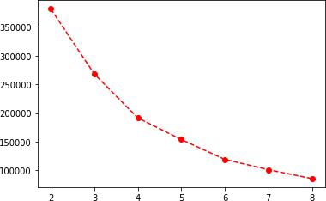

model **=** KMeans(n_clusters **=** 4)

## Input:

model**.**fit(df)

## Output:

KMeans(n_clusters=4)

## Input:

mb **=** pd**.**Series(model**.**labels_)df['Cluster']

**=** mb df

## Output:

**CustomerID Gender Age Annual Income (k$) Spending Score (1-100) Cluster**

**0** 1 1 19 15.00 39 2

**1** 2 1 21 15.00 81 2

|  |  |  |  |  |  |  |
| --- | --- | --- | --- | --- | --- | --- |
|  | **CustomerID** | **Gender** | **Age** | **Annual Income (k$)** | **Spending Score (1-100)** | **Cluster** |
| **2** | 3 | 0 | 20 | 16.00 | 6 | 2 |
| **3** | 4 | 0 | 23 | 16.00 | 77 | 2 |
| **4** | 5 | 0 | 31 | 17.00 | 40 | 2 |
| **...** | ... | ... | ... | ... | ... | ... |
| **195** | 196 | 0 | 35 | 120.00 | 79 | 3 |
| **196** | 197 | 0 | 45 | 126.00 | 28 | 1 |
| **197** | 198 | 1 | 32 | 126.00 | 74 | 3 |
| **198** | 199 | 1 | 32 | 60.55 | 18 | 1 |
| **199** | 200 | 1 | 30 | 60.55 | 83 | 3 |

200 rows × 6 columns